JOIN Queries

INNER JOIN SELECT

- SELECT o.order_id, u.name, o.order_date
FROM orders o
INNER JOIN users u
ON o.user_id = u.user_id;

This SQL query shows order details along with the user name.

It displays which user placed which order and on what date.

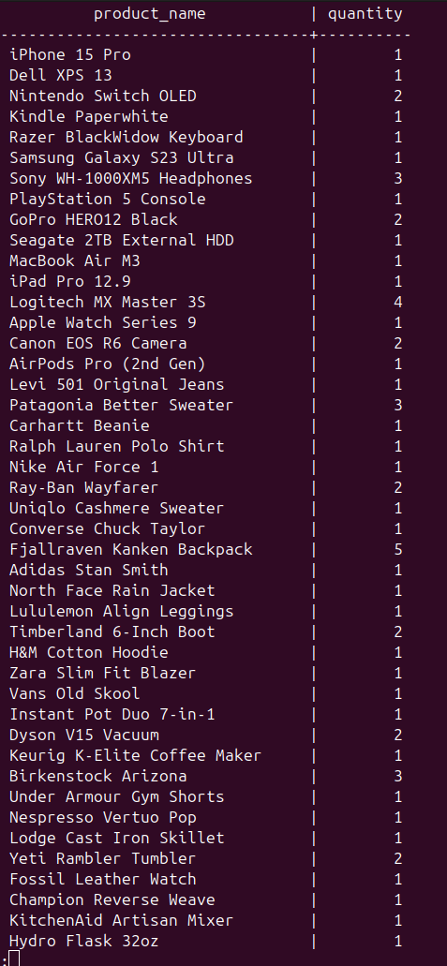

- SELECT p.product_name, oi.quantity
FROM order_items oi
INNER JOIN products p
ON oi.product_id = p.product_id;

This SQL query shows product details for each order item.

It displays which products were ordered and in what quantity.

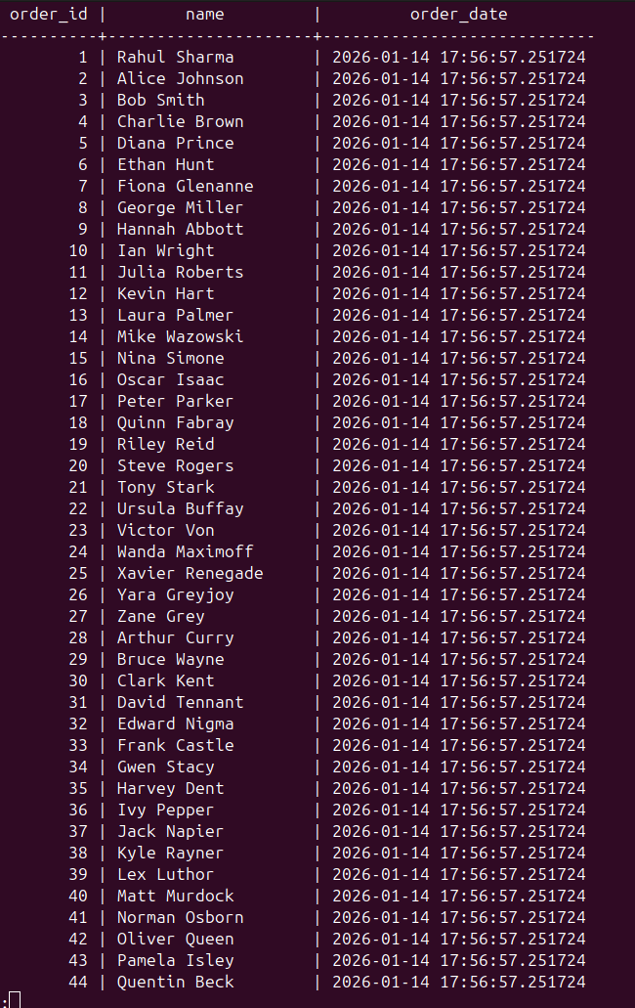

LEFT JOIN

- SELECT u.name, o.order_id
FROM users u
LEFT JOIN orders o
ON u.user_id = o.user_id;

This SQL query shows all users and their order IDs.

It displays every user and the orders they have placed (if any).

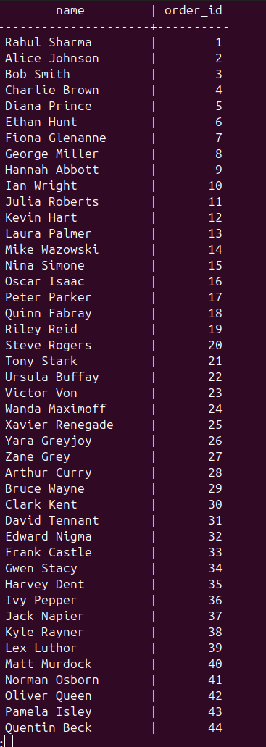

RIGHT JOIN

- SELECT u.name, o.order_id
FROM users u
RIGHT JOIN orders o
ON u.user_id = o.user_id;

This SQL query shows all orders along with the user names.

It displays every order and the user who placed it (if available).
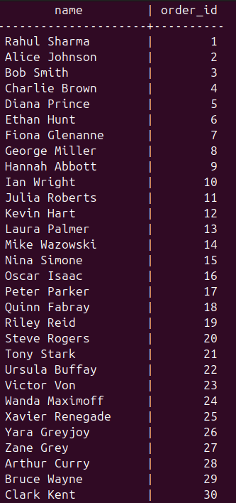

SELF JOIN

SELECT p1.product_name AS high_stock_product,
p2.product_name AS low_stock_product
FROM products p1
JOIN products p2
ON p1.stock > p2.stock;

